Press Release

GREENER, a European project to boost remediation on polluted sites, officially launched
Within the same framework, the first international workshop on biotechnology was also hosted
GREENER, a 48-month Research and Innovation Action (RIA) project celebrated its kick off meeting on the 1st and 2nd of April in Burgos, Spain, hosted by the University of Burgos.

On April 3rd, the project team organized an international workshop as well in environmental biotechnology, where international stakeholders from industry, academia, and the public exchanged perspectives and were informed of the GREENER approach.

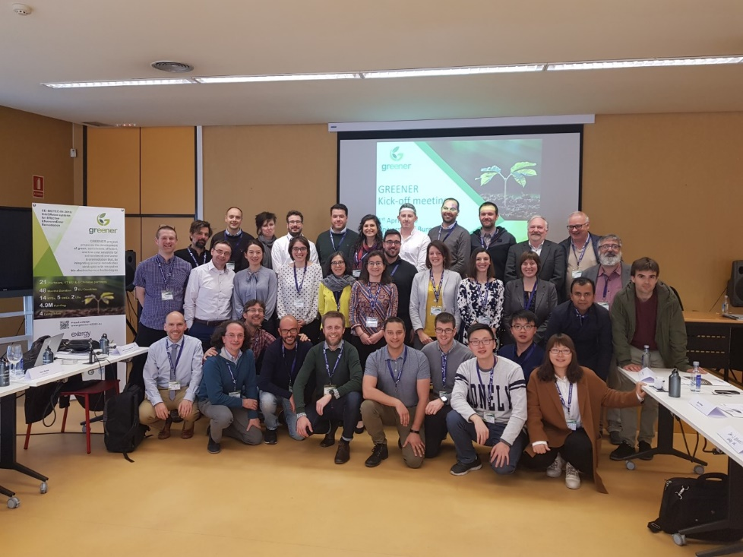

GREENER is a multidisciplinary and research-intensive innovation project involving 21 entities from 9 European countries and China (four Chinese International Partners) that proposes the development of green, sustainable, efficient, and low-cost solutions for soil/sediment and water bioremediation, integrating several innovative bio-electrochemical technologies.

The project aims to accelerate the remediation of contaminated sites, for a range of organic and inorganic pollutants of high concern, while producing end-products, such as bioelectricity and/or harmless metabolites of industrial interest. To achieve such an ambitious goal, organisms with high bioremediation capacity will be identified and isolated. The influence of physico-chemical factors on the effectiveness of treatment will be evaluated and proof-of-concept experiments to define optimal integrated solutions at the lab-scale will be performed. Finally, a combination of the most promising technologies will be up-scaled and tested on the field. Life cycle analyses will demonstrate the technical and economic feasibility of the developed solutions.

The GREENER project builds on the strong knowhow and expertise of its partners in the addressed scientific and industrial areas. Especially, the consortium is comprised of 14 research organizations (INSTITUTE JOSEF STEFAN, INSTITUTE OF TECHNOLOGY CARLOW, MATERIA NOVA, MENDEL UNIVERSITY IN BRNO, LEITAT, UNIVERSIDAD AUTONOMA DE MADRID, UNIVERSITY OF BATH, UNI BURGOS(UBU)/ICCRAM, UNIVERSITA DEGLI STUDI DI CAGLIARI, UNIVERSITY OF SURREY, QINGDAO UNI OF SCIENCE & TECHNOLOGY, ECOLOGY INSTITUTE OF SHANDONG ACADEMY OF SCIENCES, JIANGSU UNIVERSITY, NANJING TECH UNI) in Europe and China as well as 5 SMEs (EXERGY, AXIA INNOVATION, MICROGEN BIOTECH LIMITED, SUSTAINABLE INNOVATIONS EUROPE, VERTECH) and 2 large enterprise (ACCIONA CONSTRUCCION SA, TAUW GMBH) that will ensure and speed up the success of the project development.

